Dr. Alok Kumar
Correlation:Coefficient
The correlation coefficient is a statistical measure of the strength of the relationship between the relative movements of two variables. The values range between -1.0 and 1.0. A calculated number greater than 1.0 or less than -1.0 means that there was an error in the correlation measurement. A correlation of -1.0 shows a perfect negative correlation, while a correlation of 1.0 shows a perfect positive correlation. A correlation of 0.0 shows no linear relationship between the movement of the two variables.
Correlation statistics can be used in finance and investing. For example, a correlation coefficient could be calculated to determine the level of correlation between the price of crude oil and the stock price of an oil-producing company, such as Exxon Mobil Corporation. Since oil companies earn greater profits as oil prices rise, the correlation between the two variables is highly positive.
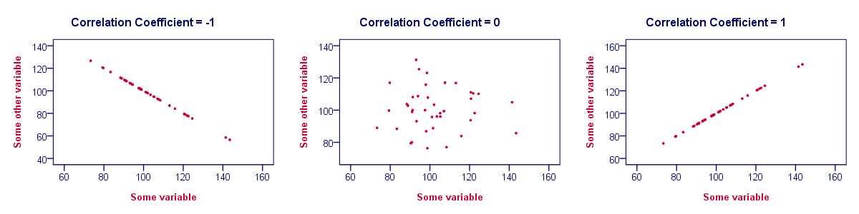

Understanding the Correlation Coefficient:

There are several types of correlation coefficients, but the one that is most common is the Pearson correlation (r). This measures the strength and direction of the linear relationship between two variables. It cannot capture nonlinear relationships between two variables and cannot differentiate between dependent and independent variables.
A value of exactly 1.0 means there is a perfect positive relationship between the two variables. For a positive increase in one variable, there is also a positive increase in the second variable. A value of -1.0 means there is a perfect negative relationship between the two variables. This shows that the variables move in opposite directions - for a positive increase in one variable, there is a decrease in the second variable. If the correlation between two variables is 0, there is no linear relationship between them.
The strength of the relationship varies in degree based on the value of the correlation coefficient. For example, a value of 0.2 shows there is a positive correlation between two variables, but it is weak and likely unimportant. Analysts in some fields of study do not consider correlations important until the value surpasses at least 0.8. However, a correlation coefficient with an absolute value of 0.9 or greater would represent a very strong relationship.

Correlation Statistics and Investing:
The correlation between two variables is particularly helpful when investing in the financial markets. For example, a correlation can be helpful in determining how well a mutual fund performs relative to its benchmark index, or another fund or asset class. By adding a low or negatively correlated mutual fund to an existing portfolio, the investor gains diversification benefits.
In other words, investors can use negatively-correlated assets or securities to hedge their portfolio and reduce market risk due to volatility or wild price fluctuations. Many investors hedge the price risk of a portfolio, which effectively reduces any capital gains or losses because they want the dividend income or yield from the stock or security.
Correlation statistics also allows investors to determine when the correlation between two variables changes. For example, bank stocks typically have a highly-positive correlation to interest rates since loan rates are often calculated based on market interest rates. If the stock price of a bank is falling while interest rates are rising, investors can glean that something's askew. If the stock prices of similar banks in the sector are also rising, investors can conclude that the declining bank stock is not due to interest rates. Instead, the poorly-performing bank is likely dealing with an internal, fundamental issue.

Correlation Coefficient Equation:-
To calculate the Pearson product-moment correlation, one must first determine the covariance of the two variables in question. Next, one must calculate each variable's standard deviation. The correlation coefficient is determined by dividing the covariance by the product of the two variables' standard deviations.
where:
​ρxy​= Cov(x,y)/ σx ​/* σy​
ρxy=Pearson productmoment correlation coefficient
Cov(x,y)=covariance of variables x and y
σx​=standard deviation of x
σy​=standard deviation of y​
Standard deviation is a measure of the dispersion of data from its average. Covariance is a measure of how two variables change together, but its magnitude is unbounded, so it is difficult to interpret. By dividing covariance by the product of the two standard deviations, one can calculate the normalized version of the statistic. This is the correlation coefficient.

